CallScripter Tutorial

Creating a *Send Email* Report

By Shane Swenson

21st October 2013

# Introduction

This tutorial will show you how to create a template for sending out an email in a script. It describes the steps we take at OracleCMS when creating all of our email templates, so it is a standard that should be followed.

In CallScripter, this is done by creating a report. However, this report will actually only be used for the purpose of creating the template of the email we want our script to send out – we will not actually schedule the report to be automatically sent to the customer as we would with a call report. This includes the fields we want included in the email, as well as the order they appear and the layout.

Once the report has been created, you can select in the Report field of a Emailer – Preview – In Body control in your script to send the email out.

# Access the Report Designer.

Starting from the CallScripter main menu, select Reporting System, and then Report Designer.

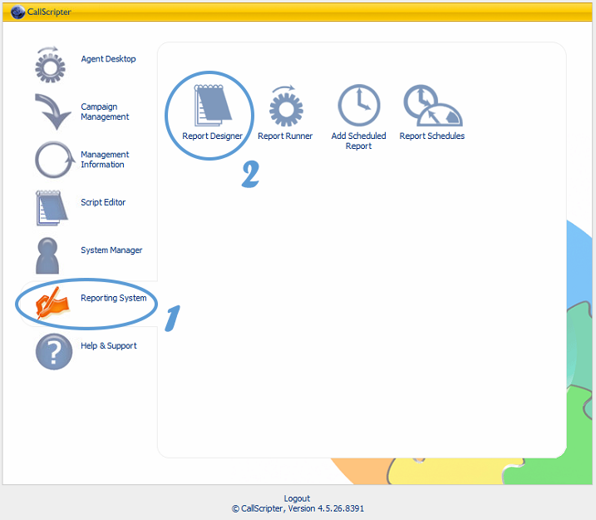

# Create a new, empty report.

Find your script from the list at the top left, and double click on it to open it.

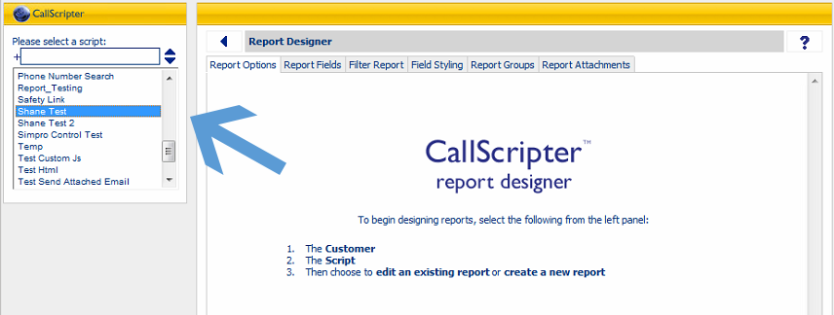

This will show you a list of the reports that exist for the script already. If you have not created any reports for this script yet, then the list will be blank. Create a new one by clicking the Add button.

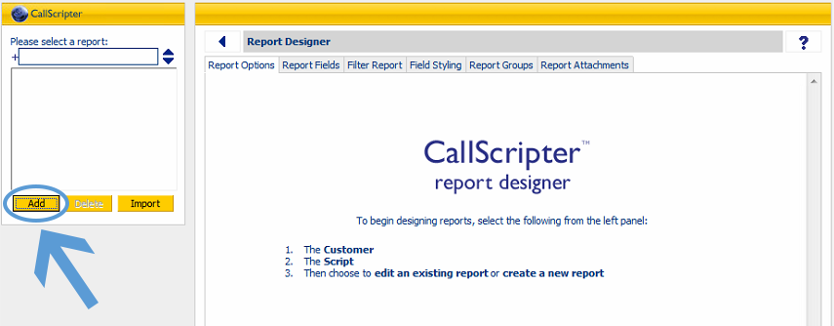

Enter a name for the report and press OK. We generally name it using the script’s name (or part of the script’s name, if its name is long), followed by Email or Send Email. This makes the email template easy for someone else to find later on should they need to make changes to it, as we often create multiple reports for each script. For example, you might also have a Monthly Call Report or a Send SMS report.

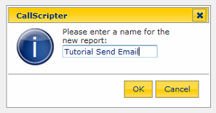

The newly created report will now appear in the list at the top left. Double click on it to open it.

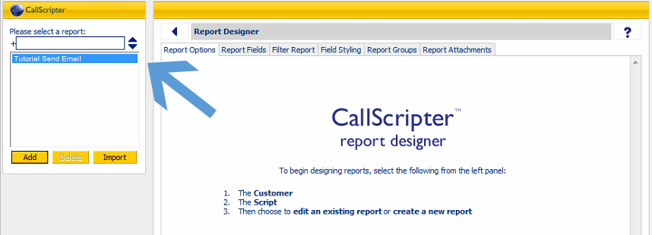

# Setting up the Report Options.

After opening up the report, you will see a list of options as shown in the screenshot below. To keep the tutorial simple to follow, I will explain only the ones that we need to use for an Email template.

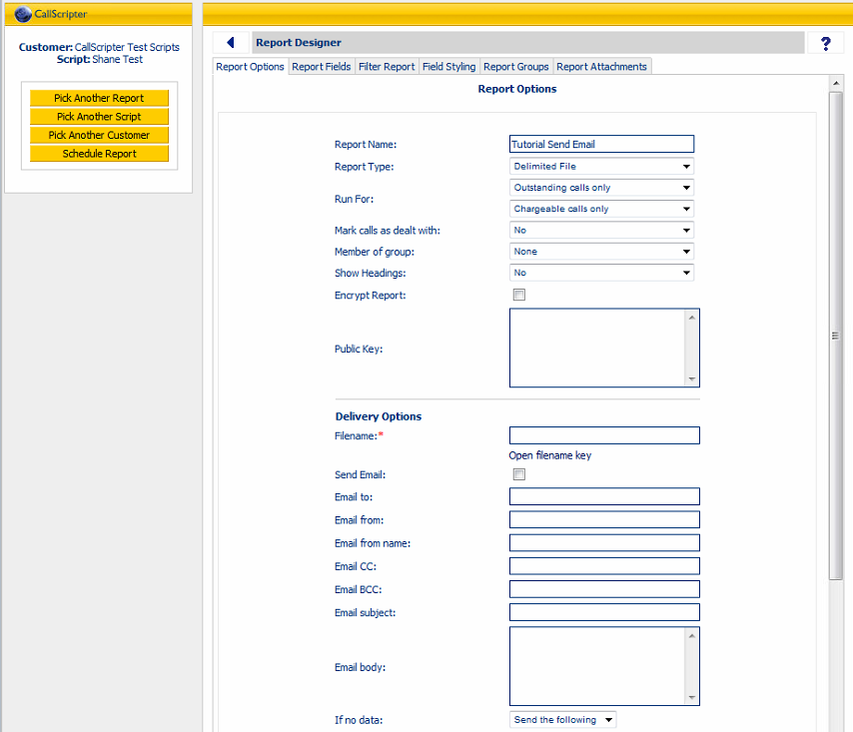

Here are the Report Options you should set when creating a report for an email template. The rest of the options can be ignored.

Starting with the options at the top of the list (above the line):

* Report Name:This will be set automatically to what you named the report when you created it. However, should you need to change the name, you can edit it here.
* Report Type:Set this to Plain Text Template.

The remainder of the options at the top of the list (above the line) don’t have anything to do with a report used for sending an email from within a script and can be ignored.

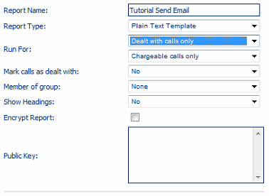

**See next page.**

As for the Report Options below the line, these ones are important (see next page for a screenshot).

* Filename:I don’t think this actually matters, but we always use a filename similar to the report name, without any spaces, and ending in .txt. For example, for a service called Shane’s Computer Services, we may call the file ShanesComputerServicesSendEmail.txt.
* Send Email:This should be ticked.
* Email to:Set the To address for the email. This should be an email address specified by the customer; the address where they want the emails sent from the script to go to. You can list multiple by separating them with commas (but do not use spaces) – for example:

[shane@oraclecms.com,ken@oraclecms.com,xavier@oraclecms.com](mailto:shane@oraclecms.com,ken@oraclecms.com,xavier@oraclecms.com)

* Email from:For a Send Email report, you can just use [reports@oraclecms.com](mailto:reports@oraclecms.com).
* Email from name:This should be set to the name of the service.
* Email CC:This is optional. If the email should be carbon copied to another address(es), enter them here. Again, you can enter multiple addresses if you separate them with commas.
* Email BCC:This should be set to audit@oraclecms.com. This allows us to keep an extra copy of the email for ourselves as proof that we sent the email, should it come into dispute with the customer.
* Email Subject:It is important that you do not leave this blank, as otherwise the email will not be sent out. If the service is a simple messaging service, we generally use MESSAGE FROM ORACLECMS as a subject. If the customer has multiple services with us, then the name of the service would be a better choice so that the customer can differentiate easily.
* Place Report In Body:Should be set to Yes, send in body.

There are another two things we need to do, however, the options are specific to the Plain Text Template report type, and will not appear until after we have saved the report after having set that option. So press the Save Options button at the bottom now.

Once you’ve done that, you will have an extra option:

* Hide Empty Fields:Should be set to Yes.

**See next page.**

After setting up the Report Options at the bottom half of the list, your settings may look a bit like the below. As previously mentioned, the Hide Empty Fields option and Generate Template button will not appear until after you have clicked Save Options, with Plain Text Template set as the report type.

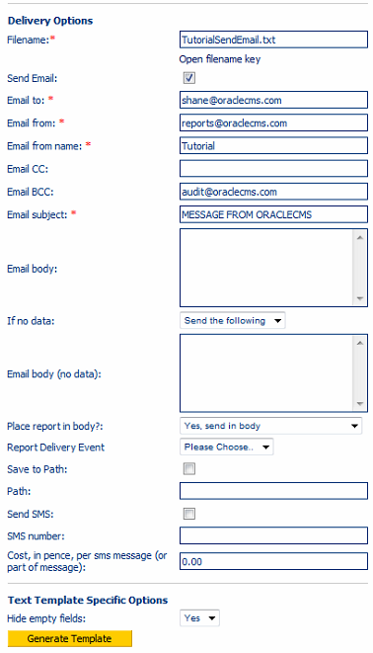

**See next page.**

# Setting up the Report Fields.

Click the second tab at the top of the window called Report Fields. You should see the below.

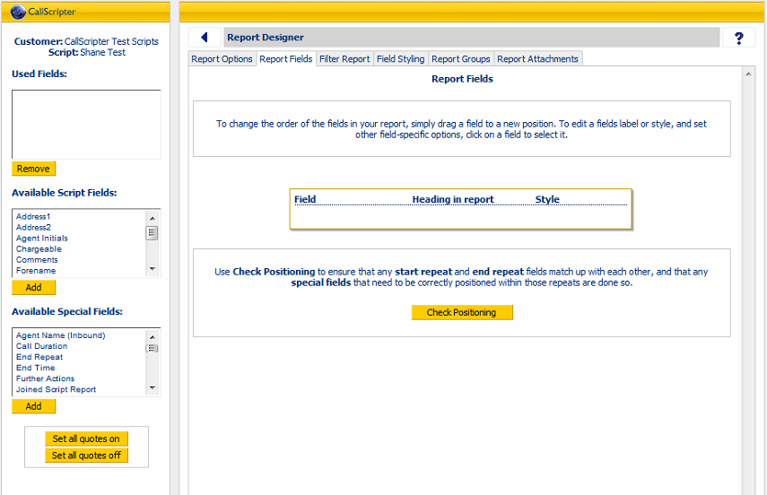

On the left are fields that you can add to be included in the report – ie. Contained in the body of the email that will be sent out by your script.

You should always add these two first:

* Under Available Special Fields, double click on Start Time and Session ID.

The first one is the time and date when the script opened – ie. when the caller called us.

The second is a reference number for the call automatically generated by CallScripter. We can look up the details of a call easier later on using this reference number, so it is useful to give it to the customer as they can quote it when inquiring about a particular call.

**See next page.**

After adding these two fields, it should look like this:

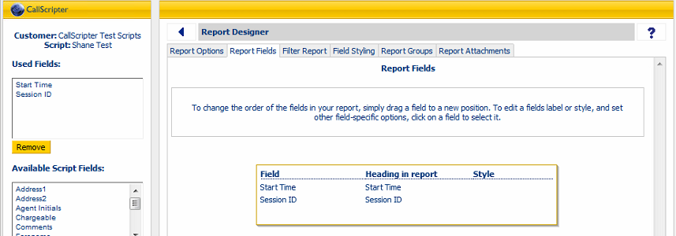

Note that the two fields have been added to the list at the right, and also in the list at the top left. We don’t really need to worry about the list at the top left as we can see everything clearly at the right.

For the list at the right, the field names are written down the left, and the headings as they will appear in the email are written down the middle. If you click on a field, you will get some options at the top left, as shown:

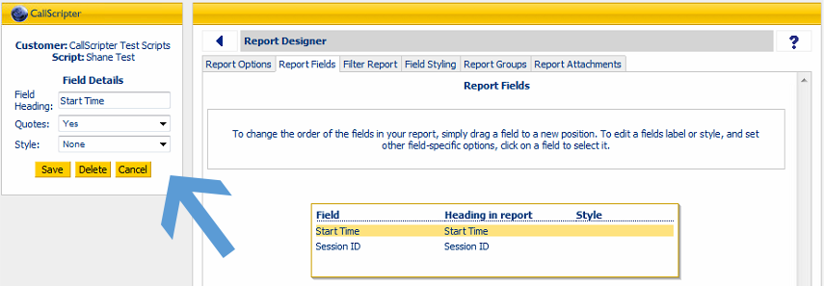

Here, you can change the field heading, whether the data should be wrapped in quotes in the email, and also any style settings that should be applied to the text.

For the Start Time field, change the heading to Date / Time and press Save.

For the Session ID field, change the heading to Call Ref No and press Save.

These are the standard heading names we use for these two fields across all reports in all scripts, so this should be followed for all new reports, whether it’s for an email template, call report, etc.

From here, you can go ahead add whatever fields you want to include in the email template. Here are some more notes on standards that we follow:

* You should add the fields in a logical order – for example, it would be a good idea to add the field that the agent would input into the script first, let’s say the Enquiry Type, followed by what is entered next, perhaps First Name and Surname, and so on.
  + Note that the First Name control is usually actually named Forename – this name is a bit weird in Australian English, so you should rename its heading to First Name.
  + As for the address fields, you should change the following:

Address1 and Address2: Add a space between Address and the number.

OZ Locality: Suburb

OZ State: State  
PostCode - Hopewiser - V2: Postcode

* Any fields that are made up of text, should have the Uppercase style applied to it. This would include, but is not limited to, First Name, Surname, Address, Suburb, State, Message, etc. Adding it to a Phone Number or Postcode field is not needed as these should be only numbers anyway.
* Once you have added all fields, click the Set All Quotes Off button in the bottom left. This will set the Quotes option for every field to No. We do this because it looks a bit bad having quotes surrounding all of the data.
* If you want to reorder the fields after you have added them, you can do so by clicking and dragging them higher or lower on the list. The order the fields appear in the list is the order they will appear in the email. In some cases, the customer may request the information sent in the email to be presented in a specific order.

**See next page.**

Here’s what the finished list of fields looks like for my particular script:

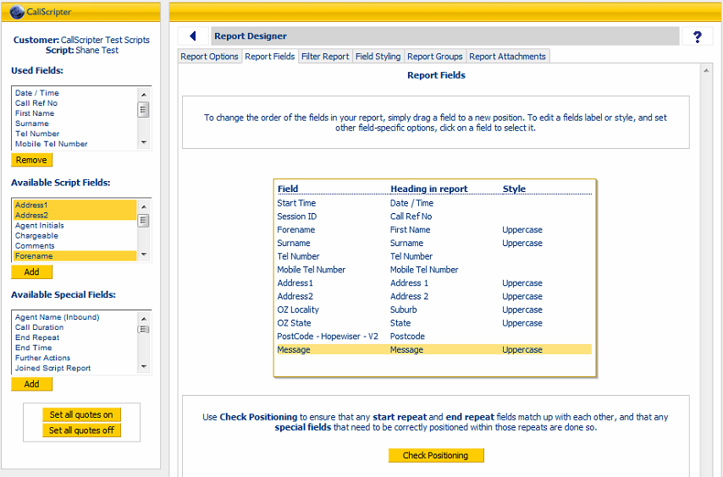

Now that this is done (make sure to click Set All Quotes Off!), click back onto the Report Options tab, which is the first one. Scroll to the bottom and click the Generate Template button.

Whenever you add, delete or re-order the list of fields, you need to go and click this button again or else there will be errors in the email that is sent out, which may mean the wrong fields or there could be fields missing.

After clicking the button, you will see a Download and Upload button appear as shown in the screenshot below. We need to do one last thing with the report before we are finished. We need to make a small edit to the template that was generated.

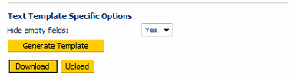

You can use the Download and Upload buttons, or alternatively, you can access the generated template file at the following location:

\\192.168.80.226\Reports\ReportTemplates\

**See next page.**

Look at the URL in the window where you are editing the report, and note the report ID at the end of the URL. For example:

<http://192.168.80.226/ReportingSystem/ReportDesigner.aspx?tabNum=1&customerID=3&scriptName=Shane+Test&reportID=2016>

The report ID for my report is 2016.

So I would open the file called Template2016.txt in the ReportTemplates folder I mentioned earlier.

In my case, the file looks like this:

Tutorial Send Email__BeginRecord__

__SPCL_CallTime_1__: __SPCD_CallTime_1__

__SPCL_SessionID_2__: __SPCD_SessionID_2__

__SCRL_Forename_3__: __SCRD_Forename_3__

__SCRL_Surname_4__: __SCRD_Surname_4__

__SCRL_Tel Number_5__: __SCRD_Tel Number_5__

__SCRL_Mobile Tel Number_6__: __SCRD_Mobile Tel Number_6__

__SCRL_Address1_7__: __SCRD_Address1_7__

__SCRL_Address2_8__: __SCRD_Address2_8__

__SCRL_OZ Locality_9__: __SCRD_OZ Locality_9__

__SCRL_OZ State_10__: __SCRD_OZ State_10__

__SCRL_PostCode - Hopewiser - V2_11__: __SCRD_PostCode - Hopewiser - V2_11__

__SCRL_Message_12__: __SCRD_Message_12__

__EndRecord__

The problem here lies with the text at the start of the file, highlighted in yellow. CallScripter, by default, will put the name of the report into the template. This means it will be included in the email we send out! To fix this, simply delete the report name from the start of the file, so that the only thing written on the first line is __BeginRecord__ and then save the file.

If you chose to Download the file, you will need to press Upload and select overwrite to adjust the template.

This is everything you need to do to create a Send Email report. You can now use it with an Emailer – Preview – In Body control to send an email from within your script.

Lastly, here’s how my particular template looks from within my script:

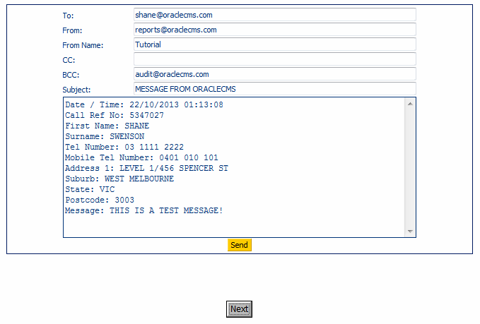

**If anything in this document is unclear or you are unsure, ASK QUESTIONS!**